FINAL PROJECT

UNIVERSITY ADMISSION SYSTEM

Akosua Asantewaa Addai

AMALITECH TRAINING ACADEMY 2021

(JAVA PROGRAMMING COURSE)

**INTRODUCTION**

A computerized admission system is the need and demand of every university today. To reach out to students at every nook and corner of the world with proper login provided, a computerized works way better than manual pen-paper system.

Primary objectives are:

* Paperless admission with computerized process
* Reduced time in activities with reduced manpower
* Cost-cutting
* Operational efficiency
* Effective integration with other institutions
* Centralized data handling
* Consistent view of data

This online Admission system has two types of accessing modes, administrator, and user. Student management system is managed by an administrator. It is the job of the administrator to admit and monitor the whole process. When a user logs in to the system, he would only view details of the student. He can't perform any changes. The system has two modules. They are: -

* User
* Administrator

Student’s logging is to apply for the course by filling an application form provided

by online. Administrator logging in may also access/search information put up by

the applicants.

**PROJECT IDENTIFICATION OF NEED**

As the strength of the students is increasing at a tremendous speed, manual

maintenance of student admission is very difficult. Hence, the need for online

admission is inevitable. In case of manual system, they need a lot of time, manpower etc. Here almost all work is computerized. So, the accuracy is maintained. Maintaining backup is very easy. It can do with in a few minutes.

**PRELIMINARY INVESTIGATION - UNIVERSITY ADMISSION MANAGEMENT SYSTEM**

STUDY OF EXISTING SYSTEM

Today in colleges student details are entered manually. The student details in

separate records are tedious task. Referring to all these records and updating is

needed. There is a chance for more manual errors.

1. When the student comes in college.

2. First, he/she takes admission form from reception.

3. Fills it and submits it into office.

4. Filled form is first checked with documents like merit list a detail came

from university and verified by an official person if there is any mistake

then it is corrected.

5. At the time of submission of it the fees are deposited by the candidate.

6. At the time of submission of admission form admission no. is assigned to

the candidate by the institute.

7. Candidate gets the receipt of fees deposition.

Disadvantages of Present System: -

1. Require much manpower i.e., many efforts, much cost and hard to operate

and maintain.

2. Since, all the work is done in papers, so it is very hard to locate a particular student record when it is required.

PROPOSED SYSTEM

The main goal of the system is to automate the process carried out in the

organization with improved performance and realize the vision of paperless

admission. Some of the goals of the system are listed below:

Manage large number of student details.

Manage all details of student who registered for the course.

Create student accounts and maintain the data effectively.

View all the details of the students.

Reduce the workload in interview the students for selection

Activities like updating, modification, deletion of records should be easier.

**ADVANTAGES OF PROPOSED SYSTEM**

The aim of the proposed system is to address the limitations of the current

system. The requirements for the system have been gathered from the defects

recorded in the past and based on the feedback from user of previous metrics

tools. Following are the objectives of the proposed system:

Reach to geographically scattered student: -

One of the important objectives of the admission system is communicated with all the students scattered geographically.

Reducing time in activities: -

Reduce the time taken process the application, admitting a student, conducting the online examination, verify student marks, and send call letters to selected students.

Centralized data handling: -

Transfer the data smoothly to all the departments involved and handle the data centralized way.

Paperless admission with reduced manpower: -

Reduce the manpower needed to perform all admission and administration task by reducing the paper works needed.

Cost cutting: -

Reduce the cost involved in the admission process.

Operational efficiency: -

Improve the operational efficiency by improving the quality of the process.

**DEFINITION OF INPUT REQUIREMENTS**

REGISTRATION & LOGIN SYSTEM

Applicants will carry out their own registration, providing the system with a

way to associate a user to their application(s). This will enable the system to display personalized information when the user logs in and certain information, such as name and address, to be added to each application automatically. Giving each student a specific ID will also allow a user to apply to several courses, while giving the system a way to prevent unnecessary duplication of applications.

Requiring a registration process will also add greater security to the system, as once a user has logged in with their username and password, they will be the only

person able to update their information and the only person to make applications on their behalf.

**APPLICATION SYSTEM**

The application process will be as straightforward as possible, using an

intuitive form layout, with the necessary information being completed in stages.

The system will monitor this and not allow a student to apply to a single course

more than once, but will allow them to apply to multiple courses in the same

college.

* **Software Requirements:**
* Java Programming Language
* Windows 7 or higher
* MS Access database
* **Hardware Components:**
* Processor –Core i3
* Hard Disk – 160 GB
* Memory – 1GB RAM
* Monitor

**VIEW STATUS**

When an application has been completed by a student, they will be able to

log in to the system at any time and view its status.

**UPDATE DETAILS**

Applicants will also be able to update their application details. Forms, much

like the ones used to register and initially apply, will be the means of inputting the

new details and will contain the previous information as a starting point. The only

time an application will be locked for editing will be when it has been submitted for admission process that is after date of last submission, after which point the

application will no longer be accessible by the user.

**DEFINITION OF PROCESSING REQUIREMENTS**

The user interface for this system will have to be simple and clear. Most importantly, the pages must be easy to read, easy to understand and accessible. The colour scheme should be appropriate to provide familiarity with the university and

there should be no contrast issues.

There are many functions the system can perform, and these must be logically

grouped or displayed in an intuitive order to allow the user to perform tasks quickly and efficiently, without getting lost in excessive amounts of text. The system must also display a large amount of information and to avoid confusion this must be displayed in categories or in different pages. Furthermore, a small amount of information may be displayed initially, for example with a certain limit on date or amount, and the ability to view more in-depth information on the subject should be apparent.

The different information displays, and functionality objects should be

individually distinguishable, allowing the user to navigate through recognition,

rather than recall in addition, each function must provide the ability to cancel,

leaving the user with the ability to rectify mistakes, and every page should include

the ability to return to a central location of the system, ensuring that the user does

not get lost within the system with no convenient way to navigate.

The system will provide different views for different users, allowing multiple

access levels. For example, a student will only be able to see their own details and

details of their applications, whereas an administrator will be able to view all users,

applications and statistics and will have many more privileges. Being online

system, it will naturally be viewable from any computer with an internet

connection, allowing admissions from home, for example. This will provide far

more accessibility than if it were written in a language with only limited online

capability as any computer is a potential workstation, rather than relying on the

program being installed.

**DEFINITION OF OUTPUT REQUIREMENTS**

The most important function is to make the short list of students who got

admission under the circumstances made by the college.

In some cases, decisions about an application will be simple, given that the

application might be exceptionally good or exceptionally bad. If, however, an

application is like other, previous applications, the tutor may have a more

difficult decision to make and inconsistencies may be introduced. Using the

automatic ranking of applications a tutor will be able to see a list of applications

with a similar ranking. This list will have a default length of 5, for example, but this

will be extendible if more comparisons are needed, and the list will include applications of the same rank as well as slightly higher and lower ranks.

**FUTURE SCOPE - UNIVERSITY ADMISSION MANAGEMENT SYSTEM**

The future scope of this project is very broad

Few of them are:

- This can be implemented in less time for proper admission process

- This can be accessed anytime anywhere, since it is a web application

provided only an internet connection

-The user had not need to travel a long distance for the admission and his/her time

is also saved because of this automated system

**CONCLUSION UNIVERSITY ADMISSION MANAGEMENT SYSTEM**

While it may sound simple to fill out a few forms and process

the information, much more is involved in the selection of applicants than this.

Every time progress was made, and features were added, ideas for additional

features or methods to improve the usability of the system made they apparent.

Furthermore, adding one feature meant that another required feature was now

possible and balancing completing these required features with the ideas for

improvement as well as remembering everything that had to be done was a project

in itself.

Debugging can sometimes be a relatively straight forward process, or rather

finding out what you must debug can be. Since so many parts of the admissions

system is integrated into one another, if an error occurs on one page, it may be a

display error, for example, it may be the information is not correctly read from the

database: or even that the information is not correctly stored in the database

initially, and all three must be checked on each occasion. This slows down the

process and can be frustrating if the apparent cause of a problem is not obvious at

first. Language used must be simple and easy to understand and compatibility is

paramount. If this system were not designed as an entirely web-based application, it would not have been possible to recreate its current state of portability.

Overall, the system performs well, and while it does not include all the features

that may have been desired, it lives up to initial expectations. The majority of

features that are included work flawlessly and the errors that do exist are minor or

graphical.

Data Flow Chart for University Admission System

Level 1

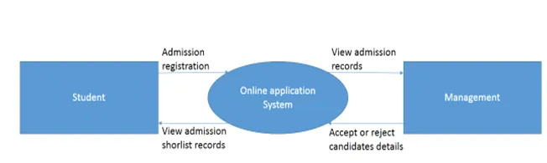

Level 2

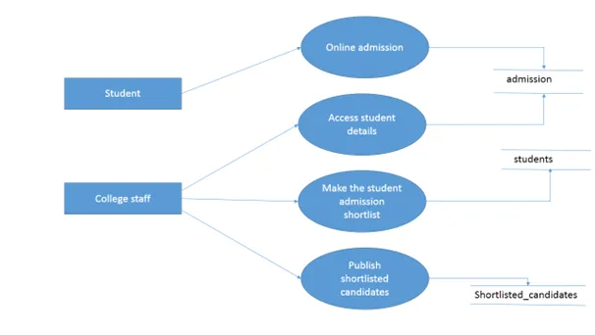

Level 3

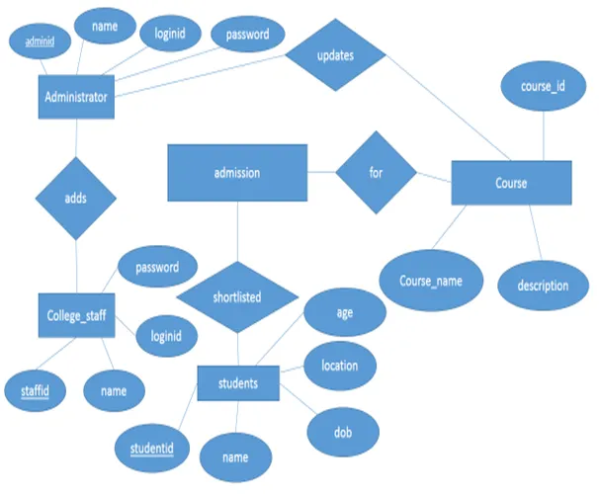

Source Code for University Admission System

public class CollegeAdmission

{

public static void main(String args[])

{

String testScoreString;

String classRankString;

int testScore;

int classRank;

testScoreString = JOptionPane.showInputDialog("Enter test score: ");

testScore = Integer.parseInt(testScoreString);

classRankString = JOptionPane.showInputDialog("Enter class rank: ");

classRank = Integer.parseInt(classRankString);

if( testScore >= 90 )

{

if( classRank >= 25)

{

System.out.println("Accept");

}

else

System.out.println("Reject");

}

else

{

if( testScore >= 80 )

{

if( classRank >= 50 )

System.out.println("Accept");

else

System.out.println("Reject");

}

else

{

if( testScore >= 70 )

{

if( classRank >=75 )

System.out.println("Accept");

else

System.out.println("Reject");

}

else

System.out.println("Reject");

}

}

}

}

References

* 1. Amit Karn, Bainay Shakya, Sunita Singh Yadav “Online Admission Systems 2008”
  2. <https://www.freeprojectz.com/project-source-code-database-download/university-admission-system-project>
  3. Samer A.K Malalha “Design and Development of Online Admission System for Al-Quds Open University in Palestine”.
  4. <https://www.scribd.com/doc/98613468/University-Admission-System>
  5. Igbe Cletus Ndop “Automated Students Admission System”

(A Case Study of Cross River State College Of Education, Akamkpa)

* 1. Admission procedure & policy (2012). Retrieved May 28, 2021, From http//www.qou.edu/english/index.jsp?pageId=25.